**ASSIGNMENT 8.4**

**PIG SCRIPTS**

XML Parsing:

grunt>

a= load '/user/acadgild/sample.xml' using org.apache.pig.piggybank.storage.XMLLoader('book') as (p:chararray);

b= foreach a generate REPLACE(p,'[\\n]','') as p;

c = foreach b generate REGEX_EXTRACT_ALL(x,'.*(?:<author>)([^<]*).*(?:<title>)([^<]*).*(?:<genre>)([^<]*).*(?:<price>)([^<]*).*(?:<publish_date>)([^<]*).*(?:<description>)([^<]*).*');

d = foreach c generate FLATTEN(($0));

STORE d INTO '/xmltocsv' USING org.apache.pig.piggybank.storage.CSVExcelStorage();

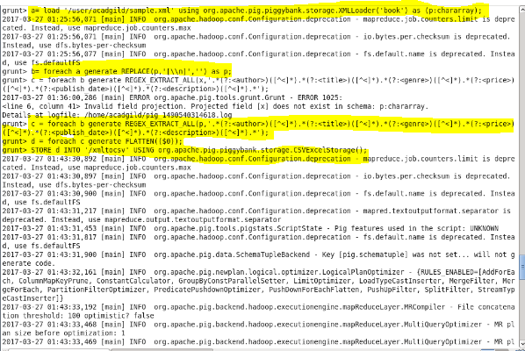

**BROWSER – VIEW – OUTPUT**

